

HAPPY PROGRAMMING
Software Requirement Specification

– Hanoi, May 2023 –

Record of changeS
Date | A*  M, D | In charge | Change Description
14/May | A | LamNB | Create Introduction
12/Jun | A,M | LamNB | Update more
26/Jun | A,M | Tuan,Dai | Update more feature
*A - Added M - Modified D - Deleted

Table of Contents
I. Overview 4
1. Introduction 4
2. System Functions 6
3. Entity Relationship Diagram 6
II. Functional Requirements 7
1. Public Feature 7
a. Home page 13
b. Sign up 14
c. Signup 16
d.View profile-cv of mentor 17
e. View all skills 19
f. View list mentor and searching 19
g. User Authorization 20
2. Common Feature 20
a. Change Password 21
b. Reset password 22
3. Mentee Feature 24
a. Update User profile 24
b. Create Request 25
c. List Request by me 26
d. Statistic request by me 27
e. Update Request 28
f. Rate & Comment mentor 29
g. List Mentor Suggestion 30
4. Mentor Feature 30
a. View list following Request 31
b. Create CV of mentor 32
c. Update CV mentor 33
d. View statistic request 34
5. Admin Feature 35
a.View list all mentor 36
b. Statistic of all mentee 38
c. View list of skills 38
d. Create skill 39
e. Update skill 40

I. Overview

1. Introduction
The tutor hiring system is a technological solution designed to help users find and hire suitable tutors based on their educational needs. The development of this system stems from the growing demand for finding and accessing quality and reliable tutors.
In today's digital era, traditional methods of finding tutors can be challenging and inconvenient. Users often have to rely on limited sources of information such as bulletin board advertisements or local tutoring centres. The process of searching, comparing, and selecting the right tutor can be time-consuming and laborious.
The tutor hiring system addresses this issue by providing a convenient and user-friendly online platform. Users can search and browse through a list of registered tutors within the system, with detailed information about their expertise, experience, previous student reviews, and required fees.
The system also offers tools and features that facilitate communication, information exchange, and confirmation of tutor hires. As a result, finding a suitable tutor and scheduling tutoring sessions becomes faster and easier than ever before.
Moreover, the tutor hiring system ensures transparency and reliability. Users can rate and review tutors after completing a tutoring session, thereby creating a trustworthy and quality-focused community. The system also ensures the security of personal information and transactions, safeguarding user privacy and confidentiality.
With the tutor hiring system, the process of finding and hiring tutors becomes convenient, quick, and reliable. Users can focus on their studies and personal development without worrying about the hassle of finding the right tutor.

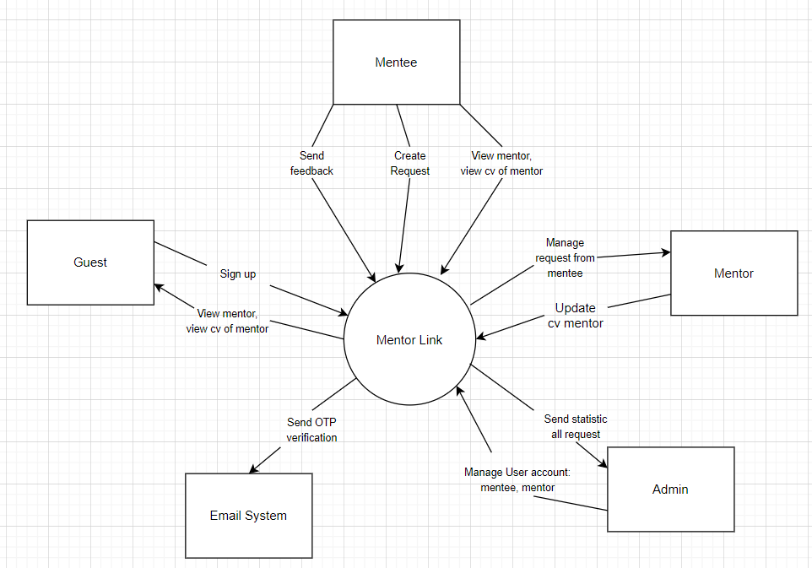

2. System Functions

a. Screen Flow
- Screen 1 : Create Request
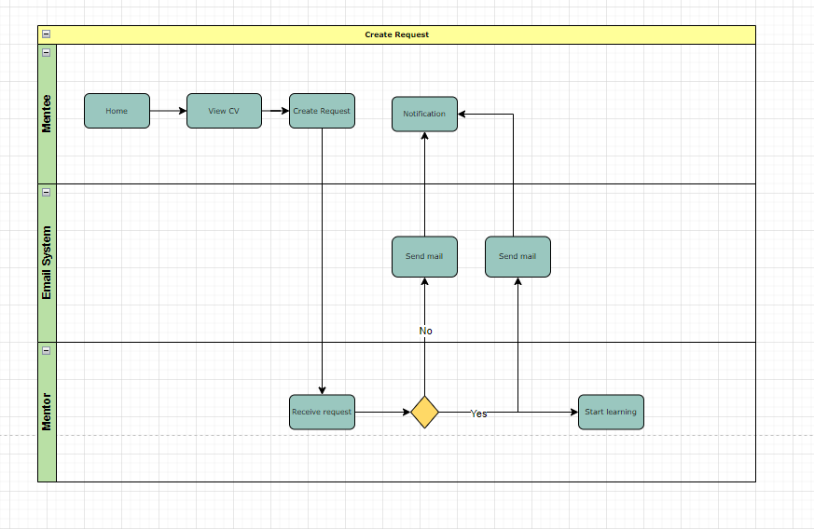
- Screen 2 : Create CV
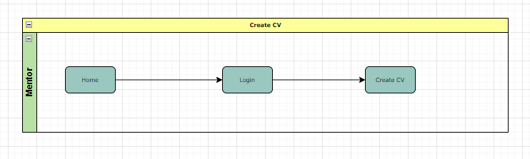
- Screen 3 : Create Skill
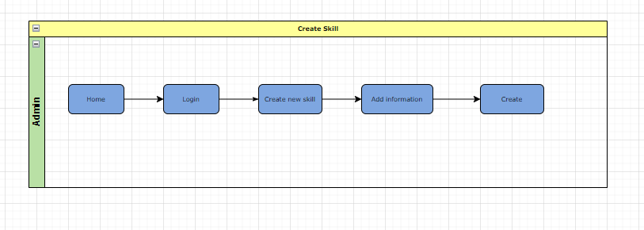
- Screen 4: Reset Password
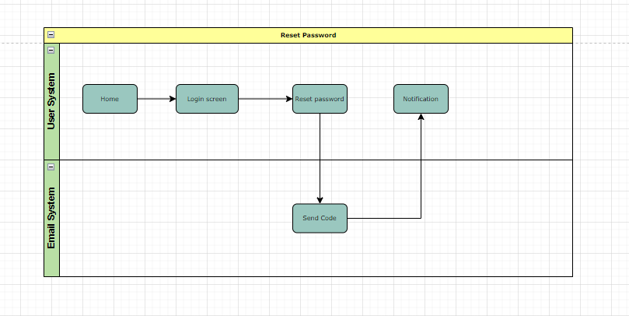

b. Screen Details
# | Feature | Screen | Description
1 | Home Page | Public | The screen shows the home page :header, body, footer, show the top list mentor , and top list skill accept mentee connect many times and more information about top mentor in homepage.
2 | Sign up | Public | System displays profile-cv of that mentor, including: fullname, account, avatar, job, introduction, rating star & comment, statistic rating of each skill, service, achievement
3 | Sign in | Public | This is a pop-up screen which allows the user to enter email & password to login; on this page, there are also options for user to register new information or reset the password for the case s/he forget it
4 | Reset Password | Common | The user input his/her email to receive the reset password link. This link is sent to the user's email for his/her code confirmation.  - Then verify code confirm successful, the user is redirected to the password resetting page in which s/he input new password (twice) for the system access  - Note that the link is only available for a specific time duration as configured in the system config file.
5 | Update User profile | Mentee | This page allow Mentee update his profile include avatar (link avatar of mentee), account name, full name, date of birth, email (only show, not allow to change the email) , sex, address and OK button
6 | List request by me | Mentee | Show the list of requests belonging to Mentee.  Title of page is List of requests"  This page allows Mentee users to see all new requests of his/her.  Show the Title (subject) of request, deadline date, deadline hour, description of request, skills selected on create request screen and the, Update, Delete button.
7 | Rate & comment mentor | Mentee | This page rates the star, comment text and OK button.
8 | List Mentor suggestion | Mentee | This page shows the list of mentors mapping the skills created requests.
9 | List of inviting request | Mentor | Show the list of requests may be one or more mentees invite the Mentor.  Title of page is List of invited requests"  This page allows the Mentor to see all the invited requests to his/her.  Show the Title (subject) of request, deadline date, deadline hour, content of request, skill of the request and corresponding accept, reject button of the request
10 | Create CV of mentor | Mentor | This page allows the Mentor user to declare the skills he can train the Mentee users.
11 | Update CV of mentor | mentor | This page allows the Mentor user to update the skills he can training the Mentee users.
12 | View statistic request | Mentor | This is a pop-up screen which allow the mentor to see all about the request belong to him include the number of currently accepted request
13 | View list all mentor | Admin | Has a textbox and search button. Show the list mentor info in table format include STT, ID, Fullname, accountname, profession
14 | View list all request | Admin | This page shows all requests of all mentees. This page has a search text box, button search, combobox of request status to allow admin to choose and filter, choose start date, end date of request.
15 | Statistic of all mentee | Admin | This page shows statistics of all Mentee include: Name of Mentee, accountname, Number of Mentee, Total hours of all requests, Total of skills of all requests.  Note: Group by and order by name of Mentee.
16 | View list of skills | Admin | This page show all the currently technical skills the Happy Programming Academy can service the mentee
17 | Create skill | Admin | Allow admin to add new skills including name of skill, default status is active and OK button.
18 | Update skill | Admin | Allow admin to update selected skill to update name of skill, choose status of skill in combobox and OK button. Skill has active/inactive status.
19 | Change Password | Common | Allow registered users to input account name, old password, new password, confirm new password and Enter button.
20 | Create request | Mentee | Title of page is "Create request"  This page allows Mentee users to create new requests to get support from Mentor.  Allow Mentee input Title (subject) of request, deadline date, deadline hour, content o f request, select skills (at least one checkbox and max is three checkboxes) the programming language(framework) the Mentee want to learn and OK button.  The request will has status: Open, Processing, Cancel, Closed
21 | Update request | Mentee | Title of page is "Update request"  This page allows Mentee users to update new requests to get support training from Mentor.  Allow Mentee input Title (subject) of request, deadline date, deadline hour, content o f request, select skills (at least one checkbox and max is three checkboxes) the programming language(framework) the Mentee want to learn and OK button.  The request will has status: Open, Processing, Closed
22 | View list following Request | Mentor | Show the list of requests may be one or more mentees following the Mentor.  Title of page is List of following requests"  This page allows the Mentor to see all the invited requests to his/her.  Show the Title (subject) of request, deadline date, deadline hour, content of request, skill of the request and corresponding accept, reject button of the request .
23 | View profile-cv of mentor | Public | System displays a profile-cv of that mentor, including: fullname, account, avatar, job, introduction, rating star & comment, statistical rating of each skill, service, achievement.
24 | User Authorization | Common | Implementation of authorization mechanism in the system, including the specify the role of logged-in user, his/her authorised page links (building the displayed menu items (in the front end) and preventing unauthorised access via enter the links directly).
25 | Statistic request by me | Mentee | Show a statistical list of requests belonging to Mentee.  Title of page is "Statistic of requests"  This page allows Mentee users to see statistics of all requests of his/her.  Show the Title (subject) of request, Total of request, total hours of all requests, total Mentor.
26 | View all skills | Public | Display all skills the Happy Programming Academy can train. On the screen include STT, Skill name (order by skill name)
27 | View all mentor and search | Public | Display list all mentor the Happy Programming Academy can training and has form searching follow mentor name

c. User Authorization
Screen | ADMIN | MENTEE | MENTOR | GUESTS
Home Page | X | X | X | X
Sign up | X | X | X | X
Sign in | X | X | X | X
View profile-cv of mentor | X | X | X | X
Change Password |  | X | X
Reset Password |  | X | X
User Authorization | X
Update User profile |  | X
View all skills | X | X | X
View list mentor and searching |  | X | X | X
Create request |  | X
List request by me |  | X
Statistic request by me |  | X
Update request |  | X
View list following Request |  |  | X
List of inviting request |  |  | X
Rate & comment mentor |  | X
Create CV of mentor |  |  | X
Update CV of mentor |  |  | X
List Mentor suggestion (for Mentee) |  | X
View statistic request |  |  | X
View list all mentor | X
View list all request | X
Statistic of all mentee | X
View list of skills | X
Create skill | X
Update skill | X
In which:
- Admin: They are the site managers. They will have the right to change and edit the overview of the website and manage the users who are using the application.
- Mentee: is a user who after logging in can use all functions such as hiring mentors, giving feedback
- Mentor: They are advisors. can choose the subjects they teach.
- Guest: are customers who have not registered for an account or have not logged in. only have the right to access the web to view and search for a mentor, but not the right to hire, give feedback, and many other rights

d. Non-Screen Functions
# | Feature | System Function | Description
1 | Usability | Design simple | Design based on UI UX, easy to use and view information.
2 | Authorization | System authorization every roles in system | Implementation of authorization mechanism in the system, including the specify the role of logged-in user, his/her authorised page links (building the displayed menu items (in the front end) and preventing unauthorised access via enter the links directly)
3 | Efficiency | Minimise users' actions on the screen so that they complete a task on the system as quickly as possible. | Helps minimise users' actions on the screen so that they complete a task on the system as quickly as possible.  For example, from 5 touches, down to 3 touches, you can order 1 product

3. Entity Relationship Diagram

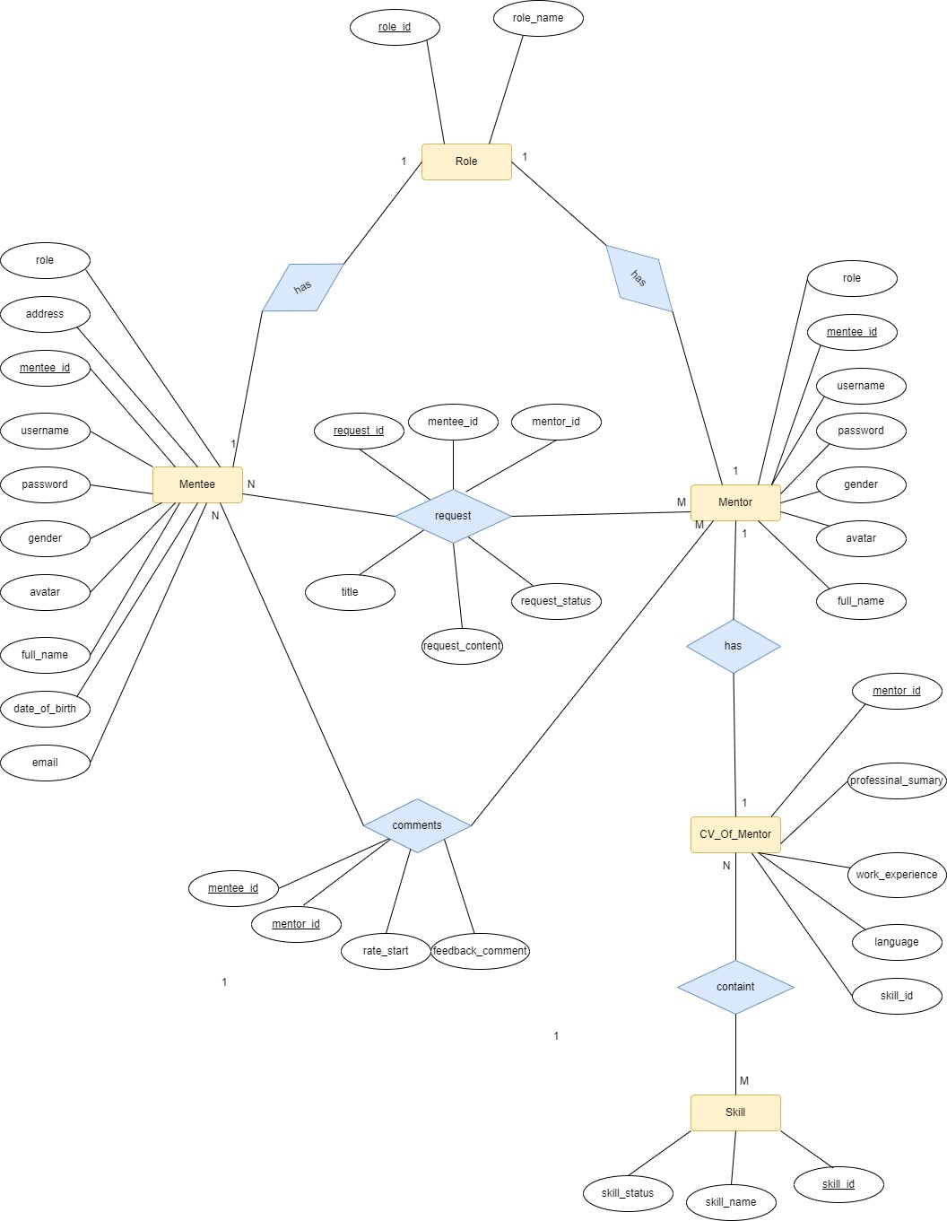
Entities Description
# | Entity | Description
1 | Mentee | Used to store system mentee information fields
2 | Mentor | Used to store system mentor information fields
3 | Role | Used to store the user's role in the system
5 | CV_Of_Mentor | Used to store information about the mentor's cv, display it for the mentor
6 | Skill | Used to store skills that the system manages
7 | Comment | Used to store information of feedback from mentee to mentor

II. Functional Requirements

1. Public Feature

Home page.
- Function trigger:
- Navigation path: When the user visits the URL of the homepage (for example, http://localhost:8082/SWP391-Team5/Home).
- Trigger from the logo: In some cases, clicking on a website's logo can also trigger the homepage.
- Automatic Triggers: The homepage can be triggered automatically in some cases, for example when a user completes a previous action on the website.
- Function Description: This page is for mentee users, mentors are used to connect with each other to learn programming, and mentors have additional sources of income. The interface includes general information about the site: top mentor, top skills, .. .Web page loads and processes data from the database
- Screen Layout :
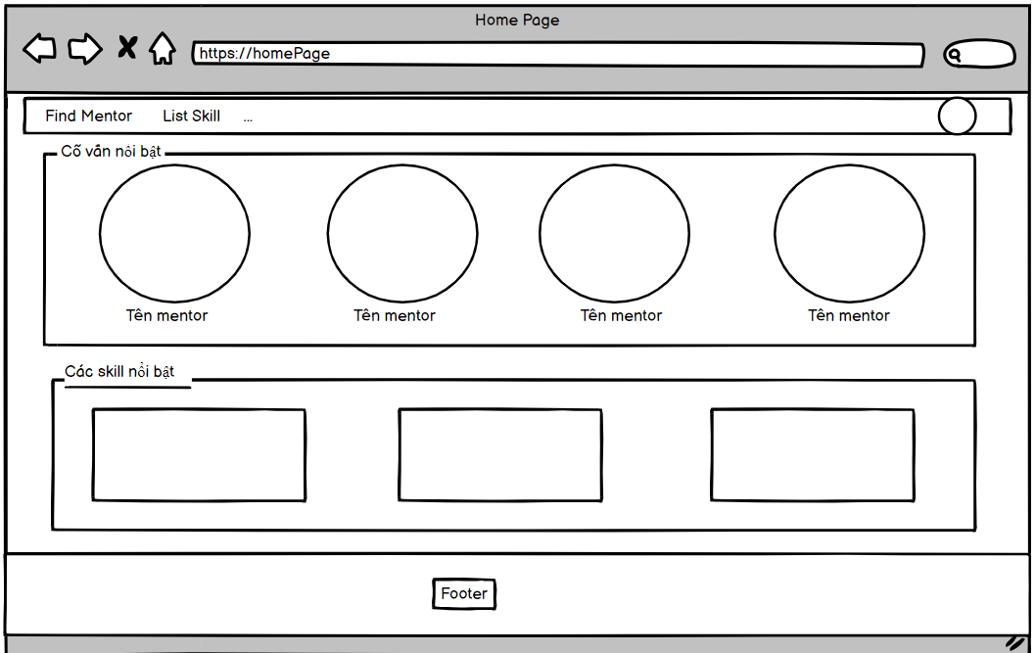
- Function Details : The screen shows the home page include :header, body, footer, show the top list mentor , and top list skill accept mentee connect many times and more information about the page.

Sign up
- Function Trigger : In the home screen the user clicks on the register button and goes to the registration page. Here the user will enter the information to be able to register an account.
- Function Description :This is a pop-up screen which allows the user to register himself/herself to the system by inputting following information: full name, gender, email, mobile, and address; User then need to verify by clicking the link sent via email to him/her before being able to access the system.
- Function details on the screen : This page shows the register/sign up form that includes username, email, password and retype password. When users fill out all the fields, our system will check your information and ensure that it is correct then send an email to the user's email which is filled above.Users will enter the code that they receive through the email in the ”Signup Verification” screen . If sign up/register successful, users will be sent to the login page to sign in/login. If your information is not correct, please refill the field that’s not correct.
- Screen Layout :

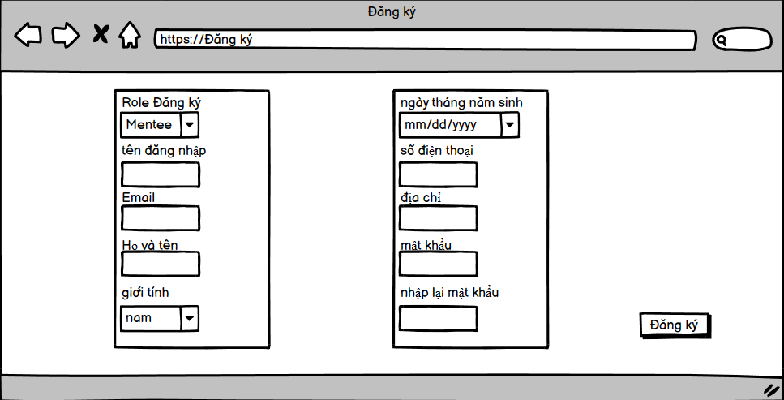
(H1)
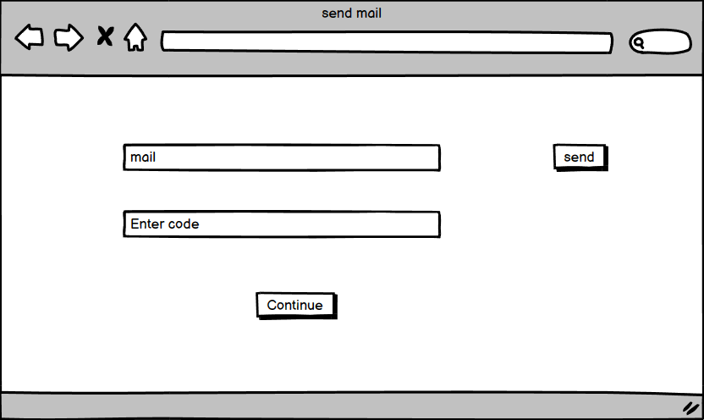
(H2)
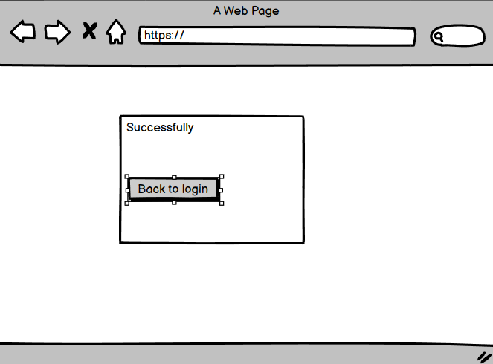
(H3)

Sign in
- Function trigger: When the user presses the Login button on the /login page, the login related functions will be called. It takes the value from the input fields "accountName" (account name), "password" (password), and "rememberPassword" (option to remember password on cookie) and performs authentication processing. .
- If the authentication is successful, the user will be redirected to the /Home page when the user role is mentee mentor, and the user role is admin will be redirected to the dashboard page. If validation fails, Displays an error message and related messages.
- Forgot password and register without an account card, used to direct users to the Sign up page and the Reset Password page respectively.
- Function Description :The Happy Programming page serves as a login portal for registered users. It provides various functionalities to facilitate user authentication and account management.
- Account Name Input: Users can enter their registered account name or username in this field. It allows the system to identify and authenticate the user.
- Password Input: Registered users can securely input their password in this field. The password is typically masked or hidden to ensure privacy and security.
- Remember Password Checkbox: This optional checkbox allows users to choose whether they want the system to remember their password. When selected, the system will store the password information for future logins, saving users the effort of entering it repeatedly.
- Sign up Link: This link provides access to the Sign up page. New users who don't have an account can click on this link to navigate to the registration page and create a new account.
- Reset Password Link: This link directs users to the Reset Password page. If a user forgets their password, they can click on this link to initiate the password reset process. The Reset Password page typically asks for additional verification information to ensure the user's identity before allowing them to reset their password.
- Function details on the screen :
- allow registered users to input account name, password, checkbox remember password, link to Sign up page, link to reset password page.
- Account Name Input: This field allows registered users to enter their account name or username.
- Password Input: This field enables registered users to input their password securely.
- Remember Password Checkbox: This checkbox allows users to indicate whether they want the system to remember their password for future logins.
- Sign up Link: This link redirects users to the Sign up page where they can create a new account if they don't have one already.
- Reset Password Link: This link directs users to the Reset Password page where they can reset their password if they have forgotten it.
- Screen Layout :
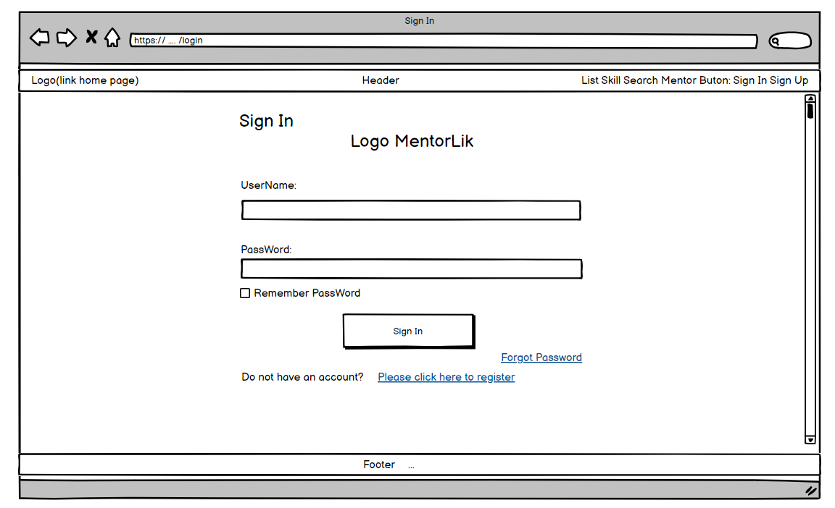

View cv of mentor
- Function Trigger: From the homepage, users can access the View CV mentor page by clicking on any mentor displayed on the home page.
- Function Description : The View CV mentor page was created to help guests, as well as mentees, easily find out information about the mentor they are about to request. In addition to the basic information they can also see the skills that the mentor can train. They can also see student ratings for mentors.
- Function details on the screen : System displays profile-cv of that mentor, including: fullname, account, avatar, job, introduction, rating star & comment, statistical rating of each skill, service, achievement.

- Screen Layout:
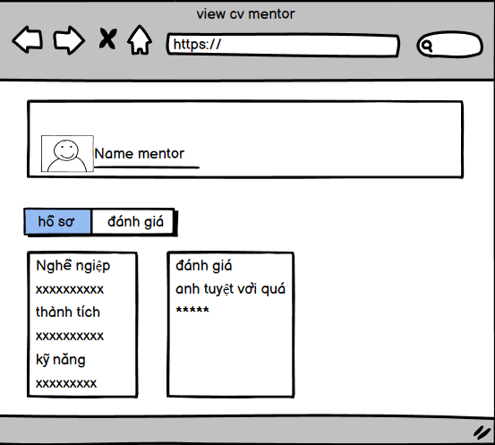

View all skills
- Function Trigger :user clicks on List All button, here user can see what skills a mentee can learn
- Function Description : Show all the skills that Happy Programming Academy can train. On the screen include STT, skill name (sorted by skill name).
- Function details on the screen: Displays a list of all the skills that the user can learn on the website
- Screen Layout :

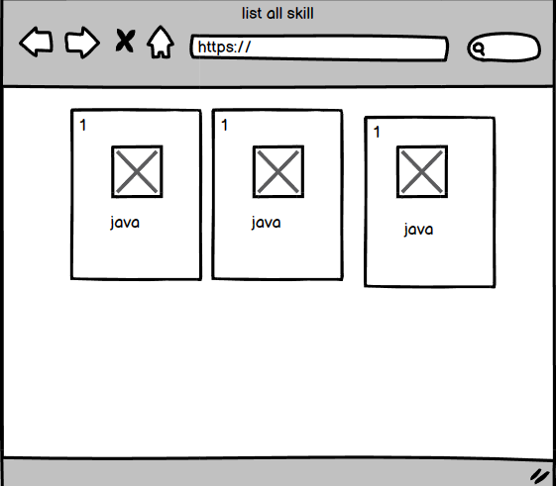

View list mentor and search
- Function Trigger: Go to the home page, click on find mentor , then it will switch to listmentor and search
- Function Description : Show a list containing all the mentors with cv in the website system, containing a textbox, filter to filter the mentors suitable for each person's connection search needs.
- Function details on the screen : Display list all mentors the Happy Programming Academy can train and have form searching follow mentor name, containing a textbox, filter to filter the mentors suitable for each person's connection search needs.
- Screen Layout :

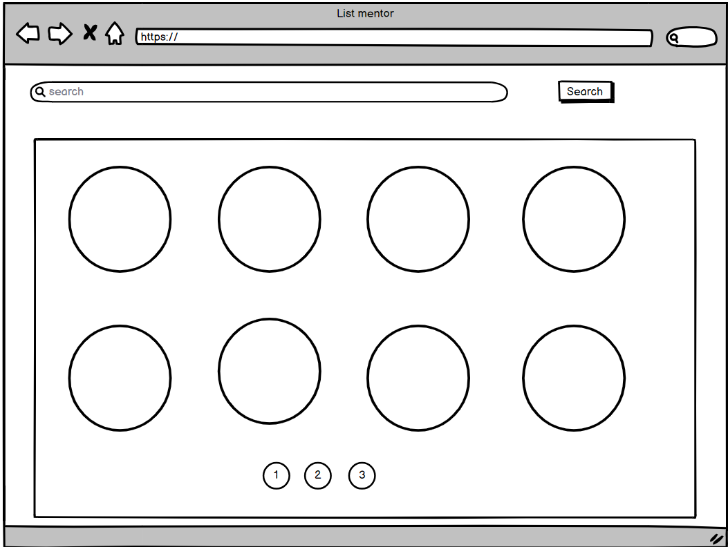

User Authorization
- Function Details:
- After authenticating the user, you can use methods like Role-based Authorization or Permission-based Authorization to assign permissions to the user. With Role-based Authorization, you can define a user's role (e.g. user, administrator) and test that role to determine access to resources. With Permission-based Authorization, you can define specific permissions (e.g. read, write, update) and check that permission to decide access.
- Function Description :
- The authorization mechanism in the system is responsible for managing user roles, determining their authorised page links, and preventing unauthorised access.
- Role Specification: When a user logs in, the system assigns a specific role to them based on their account settings or user profile. Roles can be defined as different levels of access privileges or permissions within the system. For example, roles could include "admin," "manager," or "user."
- Menu Items: The system dynamically generates the menu items displayed on the front end based on the user's role. Each menu item represents a page or functionality that the user is authorised to access. For example, an admin user may have additional menu items and access to administrative features compared to a regular user.
- Preventing Unauthorised Access: To ensure security and restrict access to unauthorised users, the system implements mechanisms to prevent direct access to restricted pages by entering the links manually. When a user tries to access a restricted page without the required role or authorization, the system redirects them to an appropriate page (such as a login page or an access denied page) or denies access altogether.

2. Common Feature

Change Password
- Function trigger: On the header bar, users can click on the avatar to bring up the drop-down menu, then click "Change password" to go to the change password page.
- Function Description : This is a pop-up screen which allows the user to change his/her password by inputting his current password as well as new password (twice)
- Function details on the screen :display the changed password website interface, the user will enter the username, password and confirm the new password. When you have filled it out correctly, you will click on the change password button to change the password.
- Screen Layout :

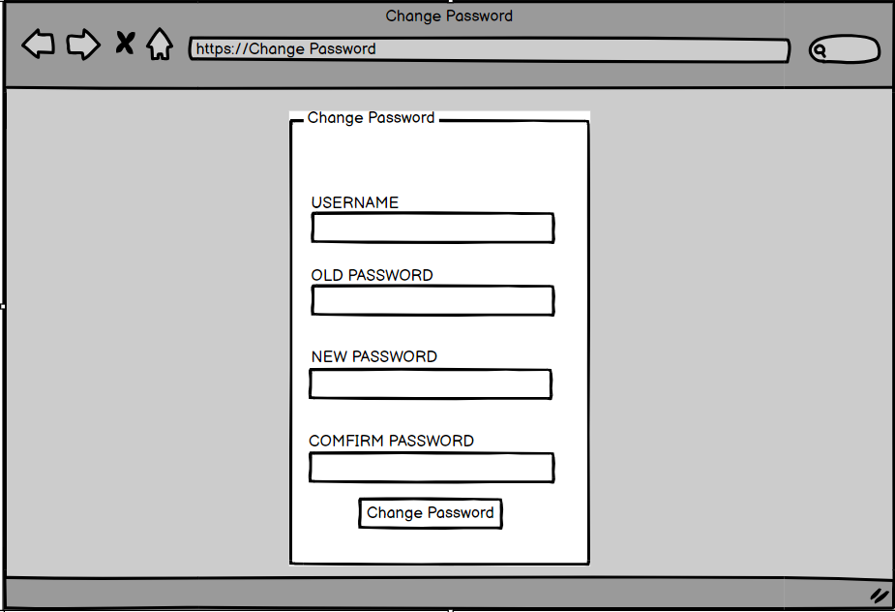

Reset Password
- Function trigger :
- Go to the homepage, go to the login interface, click on the link to forget your password, here you must provide the username and email of the account that forgot the password.
- Then click Get password to switch to the code confirmation screen, and your email has been sent to an account confirmation code by the system.
- After confirming the code successfully, go to the reset password page with 2 fields of new password, confirm the new password, then confirm to reset the password of that account.
- Function Description : Run homepage, go to the login interface, click on the forgotten password link, here you must provide the username and email of the account that forgot the password. Then click Get password to switch to the code confirmation screen, and your email has been sent to an account confirmation code by the system. After confirming the code successfully, go to the reset password page with 2 fields of new password, confirm the new password, then confirm to reset the password of that account.
- Function Details : - The user input his/her email to receive the reset password link. This link is sent to the user's email for his/her code confirmation.
- Then verify code confirm successful, the user is redirected to the password resetting page in which s/he input new password (twice) for the system access
- Note that the link is only available for a specific time duration as configured in the system config file.
- Screen Layout :

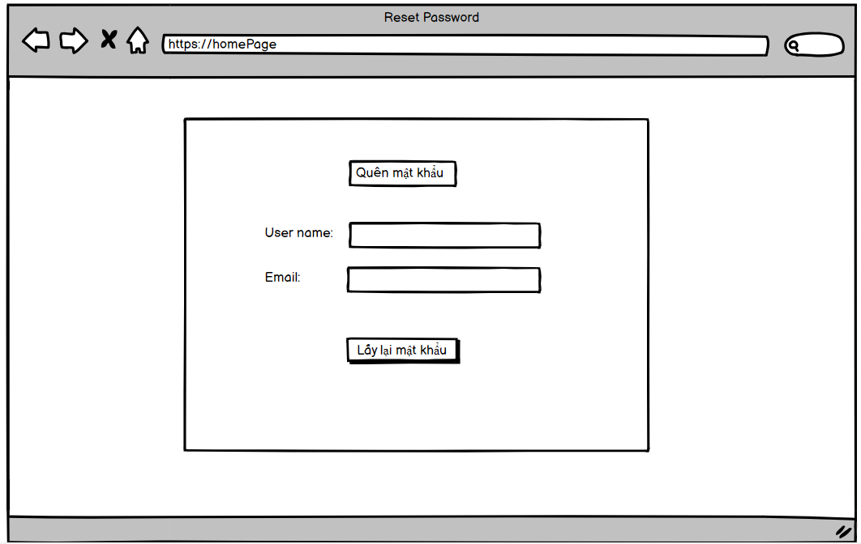
(H1)
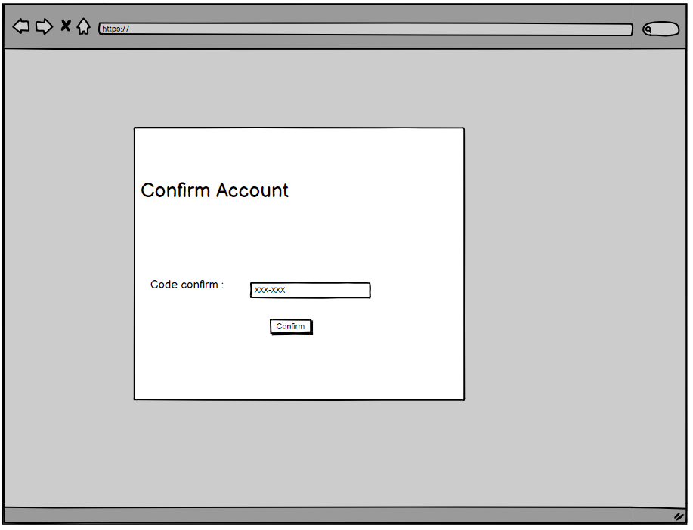
(H2)
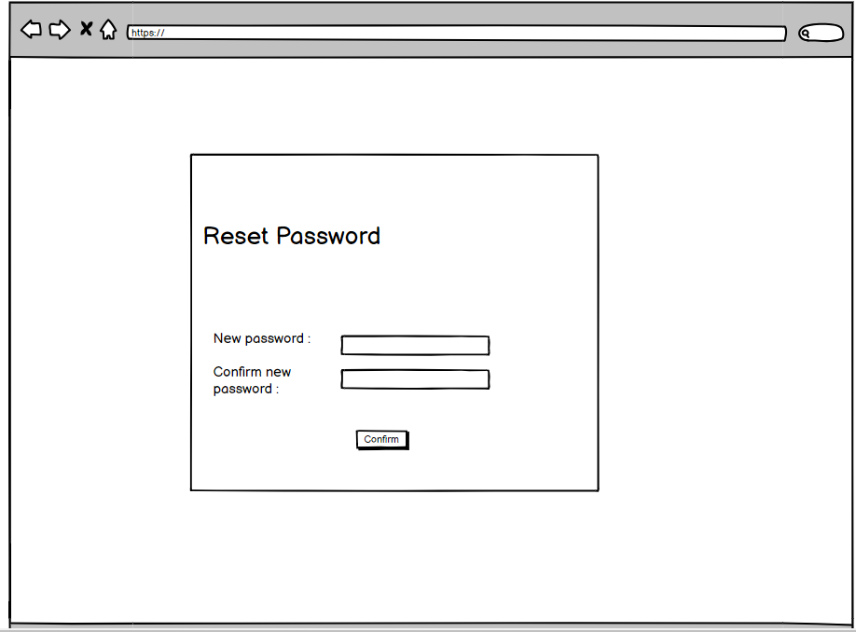

3. Mentee Feature

Update User profile
- Function Trigger: On the header bar users can click on the avatar to display the drop down then click on "View Profile" to go to the page containing personal information.
- Function Description : This page allows users to view their basic information. In addition they can also update their info as well as their profile picture.
- Function details on the screen : This page allows Mentee to update his profile including avatar (link avatar of mentee), account name, full name, date of birth, email (only show, not allow to change the email) , sex, address and OK button.
- Screen Layout :

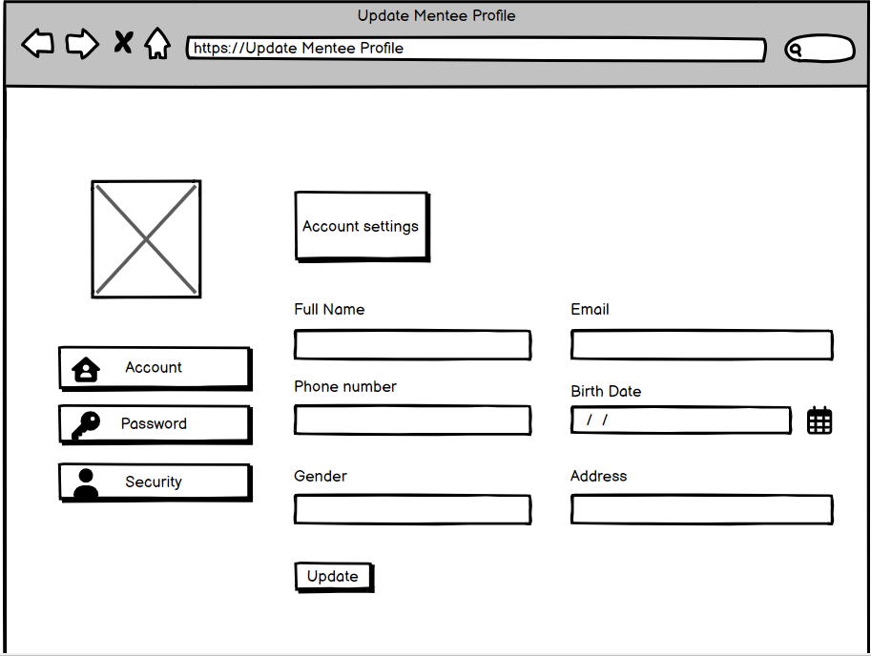

Create Request
- Function Trigger: After logging in the mentee click on view mentor's profile. then click the create request button. and will go to the create request page
- Function Description :This page allows users to send a study request to the mentor, enter information such as title, content, framework, skill (select at least 1 skill at most 3 skills), start date, end date. The request will have the status: Open, In progress, Cancel, Closed"
- Function details on the screen :Function details on the screen: when accessing the "create request" function, the guide will be redirected to a page for the user to enter the requested information and send the request to the mentor. The following details are included on the screen:
request creation table : user enters request , content , start date , end date , number of hours of study ,framework.show open , in process ,closed status
- Screen Layout:

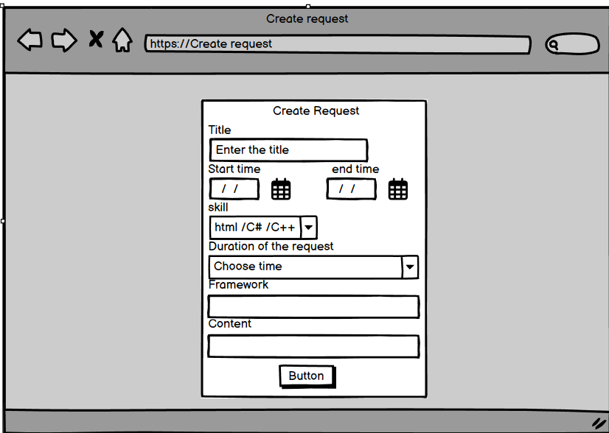

List request by me
- Function Trigger: On the header bar users can click on the avatar to display the drop down then click on "List request by me" to go to the page containing list request.
- Function Description : "Show the Learner request list. The page title is ""List request"" This page allows the Learner user to see all his new requests. Display the Title (subject) of the Learner. requirement, expiration date, expiration time, claim description, skill selected on the request creation screen, and Update, Delete buttons."
- Screen Layout:

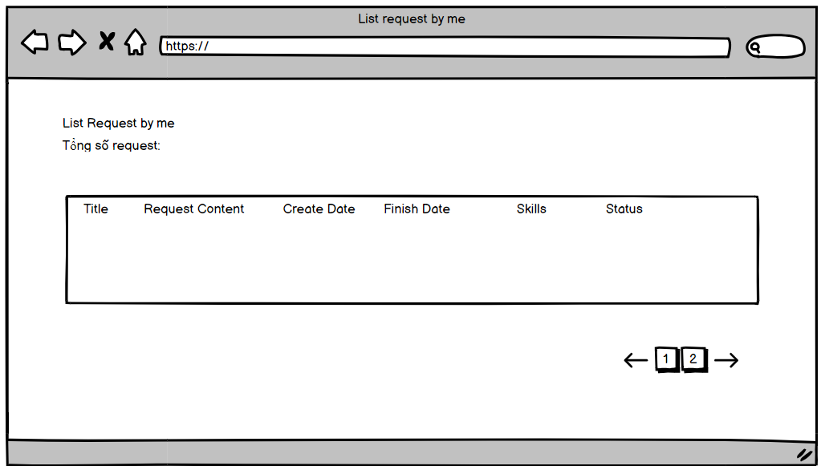

Statistic request by me
- Function Trigger: The mentee will click on the Request My Stats button below the profile picture. will give to the page information the request for user
- Function Description : This page allows the Learner user to view all his new requests. Displays the Title (subject) of the request, expiration date, expiration time, claim description, selected skill on the request creation screen, Delete button."
- Screen Layout :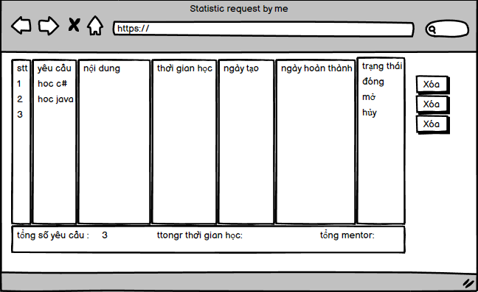

Update Request
- Function Trigger: user login with mentee account. when the user switches to the list of pages requested by me. here another request when in open state will show update button for user to update request of that request
- Function Description :This page allows users to edit their learning requirements, enter information such as lesson title, content, learning frame, skills (select at least 1 skill, maximum 3 skills), start date start, end date. The request will have the status: Open, Processing, Cancelled, Closed"
- Function details on the screen :Details of functions on the screen: when accessing the "update request" function, the instructor will be redirected to a page for the user to enter the requested information and send the request to the user. instruct. The following details are included on the display:
request creation table: user enters request, content, start date, end date, number of hours, framework.show open, in progress, status closed

- Screen Layout:
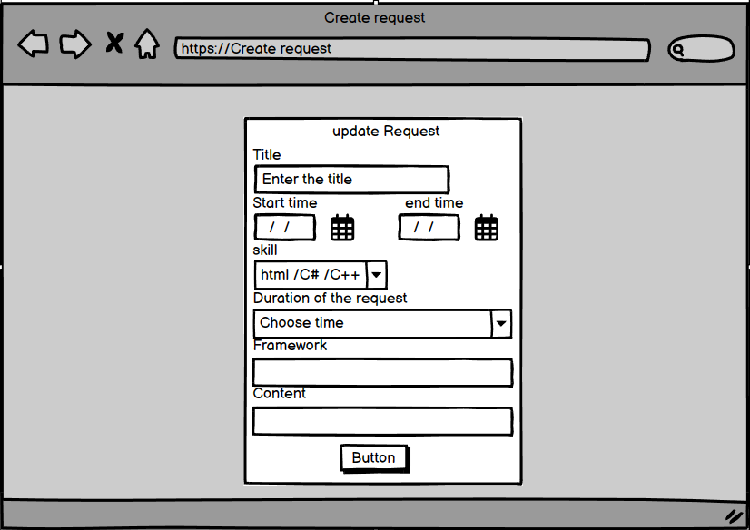

Rate & comment mentor
- Function Trigger: Click on homepage as user as mentee, click on avatar to click on list request by me . After accessing this website, show your requests and click on the end of the request to move to the comment and rate start page.
- Function Description:
-Enter comments: Users will have a text frame or interface to enter their comments.
Star rating: The commentAndRateStar() function also allows users to rate the content or product. Users can choose the number of stars corresponding to their rating, usually from 1 to 5 stars.
-Submit comments and reviews: After the user completes entering comments and reviews, the function will send this information to the system. User comments and reviews will be archived and linked to the respective content or product.

- Function Details : Enter comments: Users will have a text frame or interface to enter their comments. Star rating allows users to rate (rating) stars for content or products. Users can choose the number of stars corresponding to their rating, usually from 1 to 5 stars.
- Screen Layout :
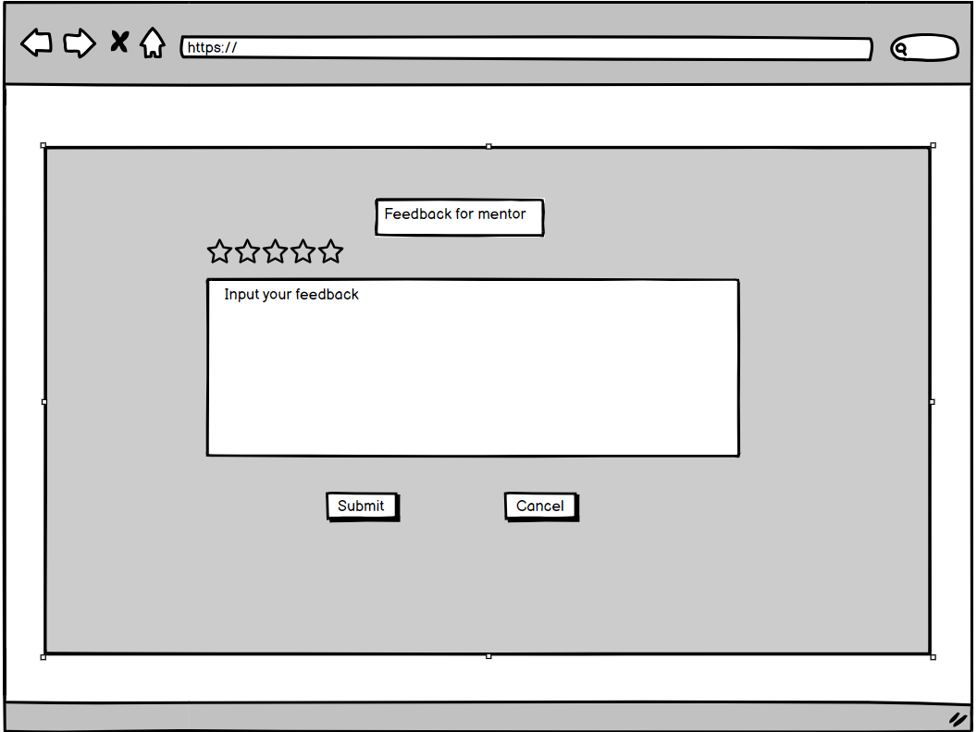

List Mentor Suggestion
- Function Trigger: On the header bar you can click on "Mentor Suggestion" to access the page containing the list of suggested mentors.
- Function Description : This page displays suggested mentors for the mentee based on the skills the mentee has selected in previous requests. Mentees can also make requests directly to mentors on this page.
- Function details on the screen : This page shows the list of mentors mapping the skills created request. The page includes: Full name of mentor, account name, rating star, the number of requests the Mentor currently has and the Invite button to allow the Mentee user to invite the Mentor he wants to get training service.
- Screen Layout:

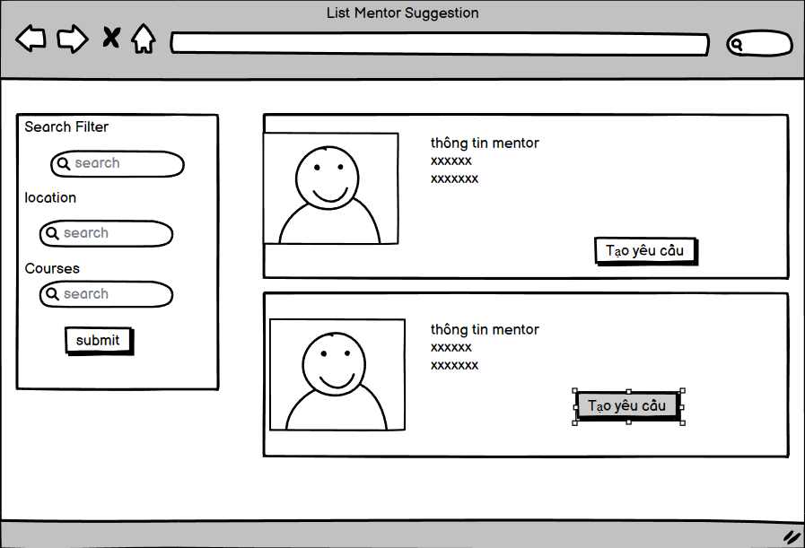

4. Mentor Feature

View list following Request
- Function Trigger : After logging in to the mentor account, users can click on the avatar to display the drop down, then click on "List Following Request" to access the page.
- Function Description : This page will show all the requests that are invited from the mentee. Mentors can monitor this list to see information about the mentee's request. The mentor can then accept or decline the request.
- Function details on the screen : Show the list of requests may be one or more mentees following the Mentor. Title of the page is "List of following requests". This page allows the Mentor to see all the invited requests to his/her. Show the Title (subject) of request, deadline date, deadline hour, content of request, skill of the request and corresponding accept, reject button of the request.
- Screen Layout:

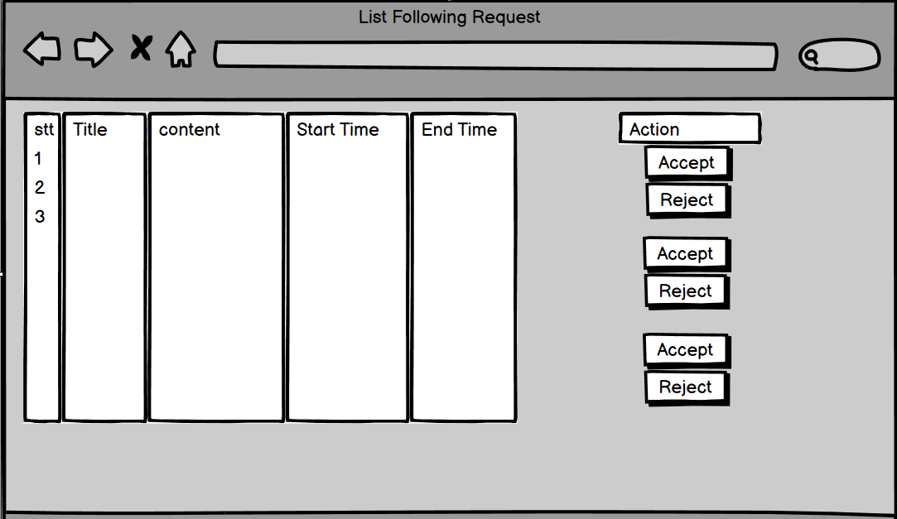

Create CV of mentor
- Function Trigger : After logging in with a mentor account, click on the avatar to display the drop down. If you do not have a CV, continue to click on "Create CV" to access the page.
- Function Description : This page allows mentors to create a CV that can provide information and skills that they can train. In addition to the above information, they can also add information related to occupation, work experience ....
- Function details on the screen : This page allow the Mentor user to declare the skills he can training the Mentee users.Title of page: "Create CV of mentor" account name, fullname, date of birth, email, sex, address, Profession, profession introduction, select skills(checkbox), service description, achievement decision, the programming (framework) the Mentor can training the Mentee and the OK button.
- Screen Layout :

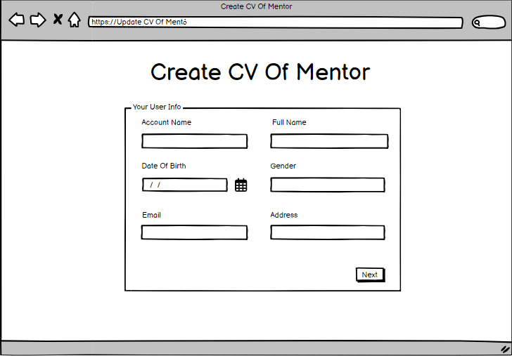

Update CV mentor
- Function trigger :After logging in with an advisor account, click on the avatar to bring up the drop-down menu. If you already have a CV, click Update CV.
- Function Description : This page allows Mentor users to update the skills they can train Mentee users with. Page title: ""Update CV of mentor"" Avatar (link to mentor avatar), name account, full name, date of birth, email, gender, address, occupation, career introduction, skill selection (checkbox), service description, achievement description, programming languages (framework) ) that Mentor can train Mentee and OK button.
- Function details on the screen :this page shows a form to Update a mentor CV including personal information, career, Career Introduction, Service Description, Achievement Decision, Programming (Framework) Trainable Mentor create.
- Screen Layout :

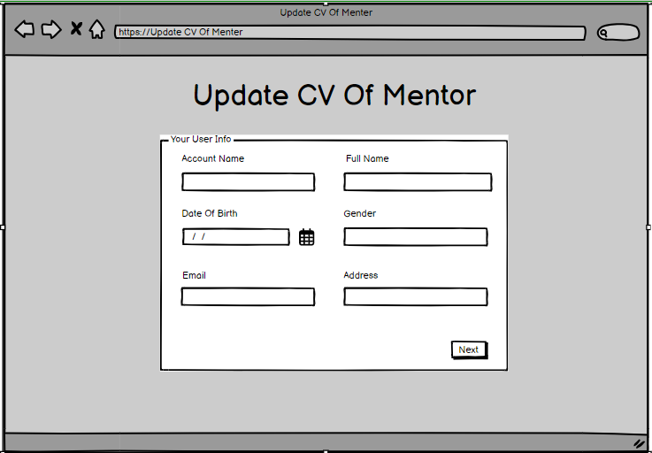

View statistic request
- Function Trigger : After successfully logging into the homepage as a mentor, the user clicks on the avatar in the header to display a dropdown and clicks on the my profile page. After entering the profile page, click on the list of statistics request section and the popup screen will appear
- Function Description : 'This is a pop-up screen which allows the mentor to see all about the request belonging to him including the number of currently accepted request, number of currently invited request, number of cancelled request, percentage of cancel request, percentage of completed request, rating star.
- Function details on the screen :this page shows a form to pop-up including personal information about the number of currently accepted requests, number of currently invited requests, number of cancelled requests, percentage of cancel request, percentage of completed requests, rating star.
- Screen Layout :
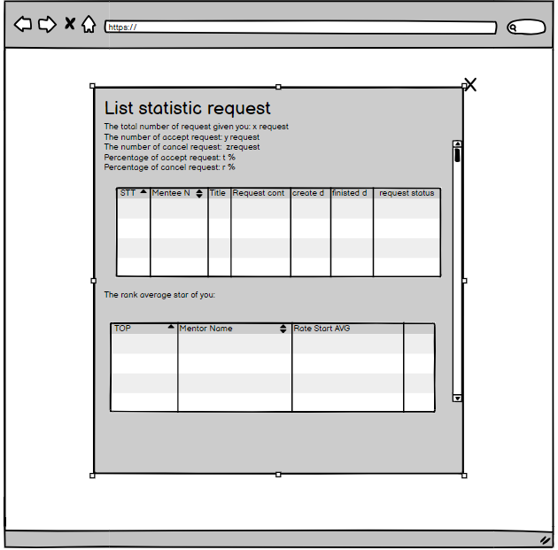

5. Admin Feature

View list all mentor
- Function trigger:
- When the user clicks the search button. When the user enters information in the textbox and presses the search button, the screen will display a book of information about the mentors in a table format.
- Function Description : The purpose of this screen is to provide a list of mentors along with their relevant information in a table format. The user can search for specific mentors by entering search criteria in the textbox and clicking the search button. The table displays various details such as mentor ID, fullname, accountname, profession, number of currently accepted requests, percentage completed, rate star, and an option to activate or deactivate the mentor. Paging functionality is also implemented to handle a large number of mentors by displaying them in smaller, manageable chunks. This screen allows the user to view and manage mentors effectively based on their information and status.
- Function details on the screen:
'Has textbox and search button. Show the list mentor info in table format including STT, ID, Fullname, accountname, profession, number of currently accepted requests, percentage completed, rate star and the link(or button) to allow active/inactive mentor. Need paging this page.
- Textbox: This is a field where you can enter search criteria to filter the list of mentors.
- Search button: Clicking on this button will initiate the search based on the criteria entered in the textbox.
- Mentor Info Table: This table displays the mentor information in a tabular format. The columns in the table are as follows:
- STT: This column represents the serial number or index of the mentor in the list.
- ID: This column displays the unique identification number assigned to each mentor.
- Fullname: This column shows the full name of the mentor.
- Accountname: This column displays the account name or username of the mentor.
- Profession: This column indicates the profession or area of expertise of the mentor.
- Number of currently accepted requests: This column shows the count of requests that the mentor has currently accepted.
- Percentage completed: This column displays the percentage of requests completed by the mentor.
- Rate star: This column represents the rating of the mentor, usually in the form of stars.
- Active/Inactive Button: This column contains a link or button that allows the user to activate or deactivate the mentor. Clicking on this link or button will change the mentor's status accordingly.
- Screen Layout :
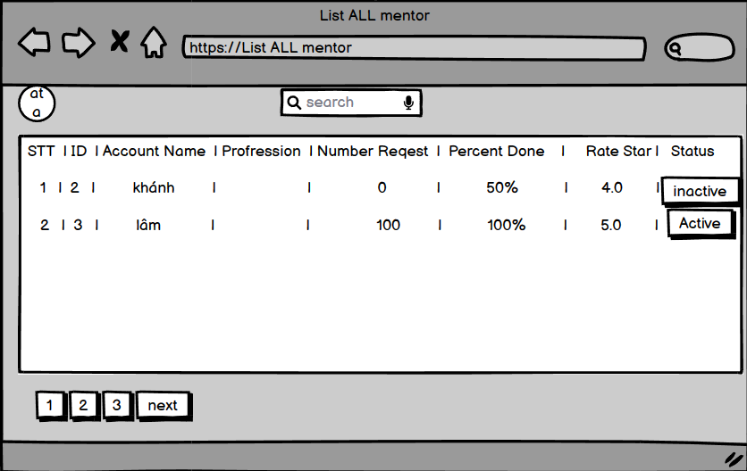
(H1)
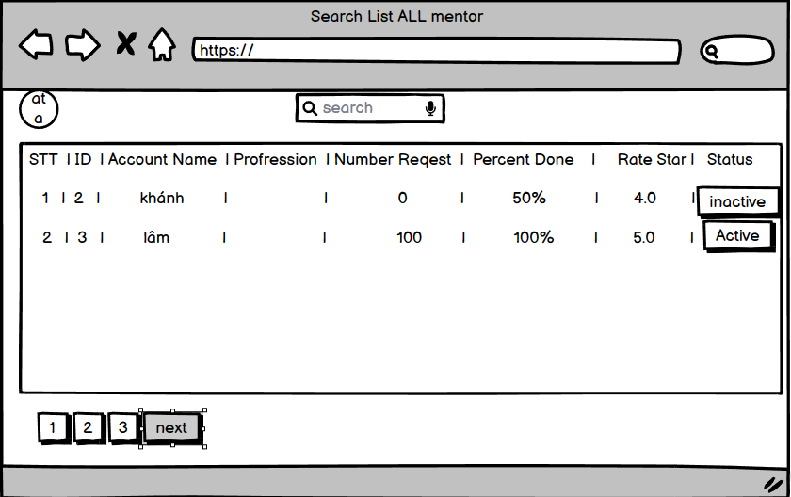
(H2)

Statistic of all mentee -

Function Trigger : After the account has the user role admin and accesses the tabs on the dashboard page, it will access these pages.
- Function Description :This page shows statistics of all Mentees including: Mentee's Name, Account Name, Mentee Count, Total Hours of All Requests, Total Skills of All Requests. Note: Group and sort by Mentee's name.
- Function details on the screen : Function details on the screen: When accessing the "View skill list" function, the administrator will be redirected to a page showing some information of the mentee. The following details will be included on the screen:
- Screen Layout :

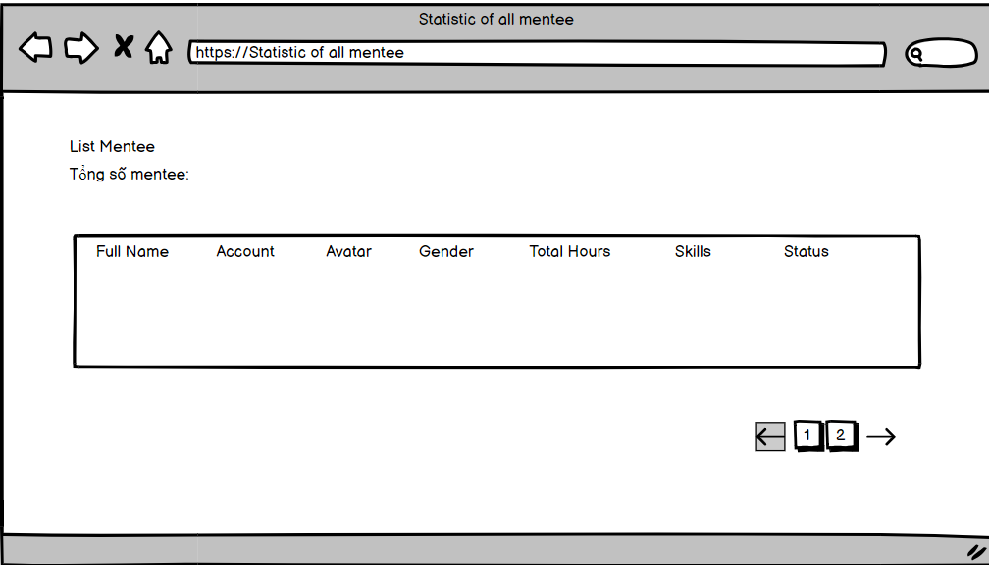

View list of skills
- Function : Used to View list of skills
- Function trigger:
- Navigation path: After the account has the user role admin and accesses the tabs on the dashboard page, it will access these pages.
- When the user visits the URL of
- /skill
- (for example, http://localhost:8082/SWP391-Team5/skill).
- Trigger from tag list-all-mentor: In some cases, clicking on a website's tag list skill can also trigger the dashboard list skill to be able to manage the skills of the course.
- Function Description : This page shows all the current technical skills the Happy Programming Academy can service the mentee. The skill info include: STT, ID, Name of skill, status (link or button) allow to enable/disable skill, link (or button) allow to update skill. The + button to allow go to create skill to add new skill.
- Function details on the screen : Upon accessing the "View list of skills" function, the mentee will be directed to a page that displays all of the technical skills currently serviced by the Happy Programming Academy. The following details will be included on the screen:
- Skill Table: A table that lists all available skills along with their corresponding Skill ID, Name of skill, and Status. The Status column will contain either a link or button that allows the user to enable or disable a specific skill.
- Update Button/Link: An update button or link will be available for each skill in the table, allowing the user to modify the existing skill information.
- Create New Skill Button: A "+" button will be present on the screen that when clicked, will direct the user to the "Create new skill" page where they can add a new skill.
- Screen Layout :
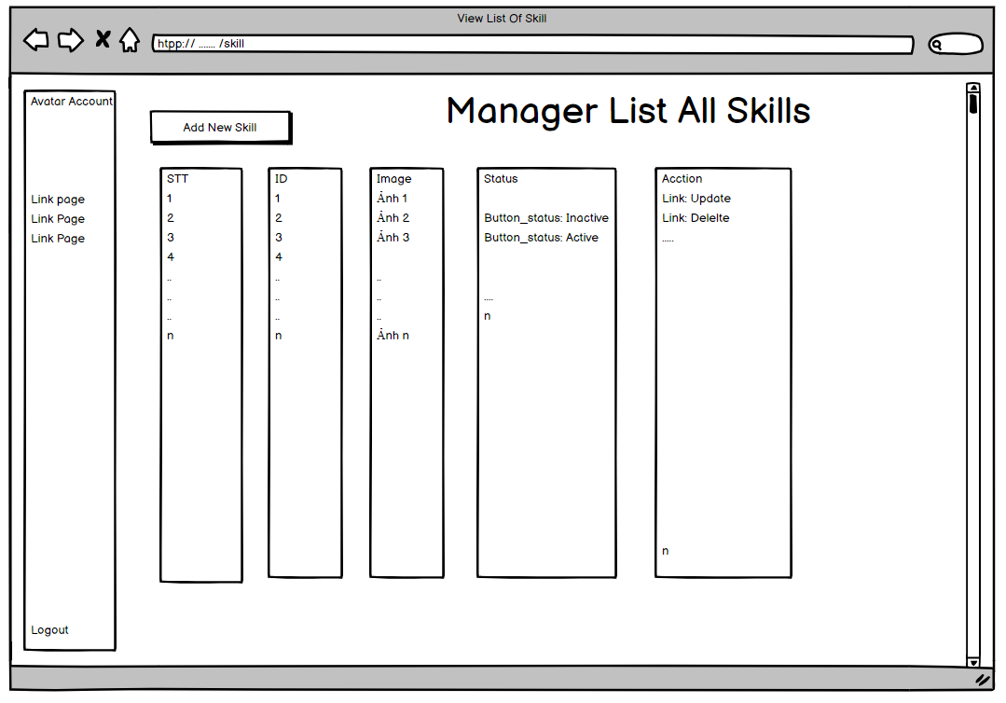

Create skill
- Function trigger :When you log in with an admin account, the skill statistics page will appear, where the admin will be able to add new skills.
- Function Description :Allows admins to add new skills including the skill's name, active default status and OK button.
- Function details on the screen : admin clicks add skill and will go to skill creation page where admin can add new skill (name, photo, status)
- Screen Layout :
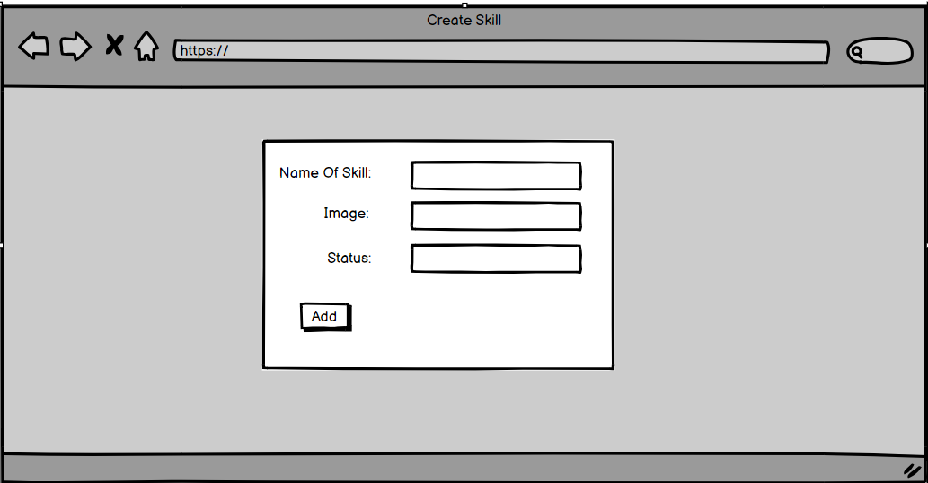

Update skill
- Function trigger:When you log in with an admin account, the skill statistics page will appear, where the admin will update the information of that skill.
- Function Description : Allows the admin to update the selected skill to update the name of the skill, select the skill state in the combo box and the OK button. Skill has active/inactive status.
- Function details on the screen : admin clicks update button and will go to update page where user can update skill information like (ID, name, photo, status)
- Screen Layout :

